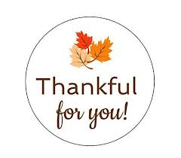

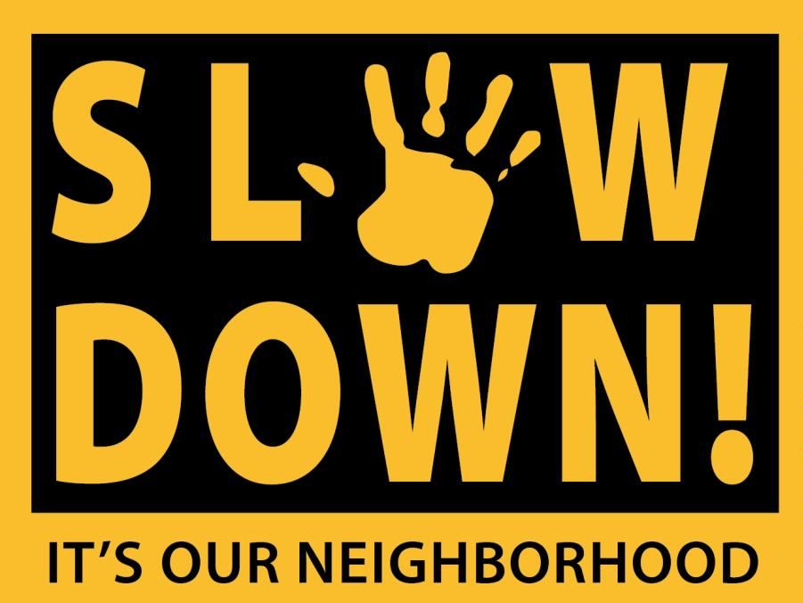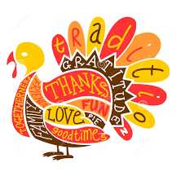

Pick up after your pets!!

If your animal defecates anywhere on our property, you are responsible for immediately removing the waste and repairing any damage. Failure to comply will result in a fine of $50.00.

Please help keep our community beautiful and clean!

The speed limit is 15 mph

throughout the entire community!

Please be respectful to your neighbors!

10 PM to 8 AM

Ugly Sweater Party – December 6th

Bingo Thursday – January TBD

Valentine Social – February TBD

We wanted to take a moment to let all

of our residents know just how much we appreciate every single one of you!

We hope you have a wonderful

holiday season!

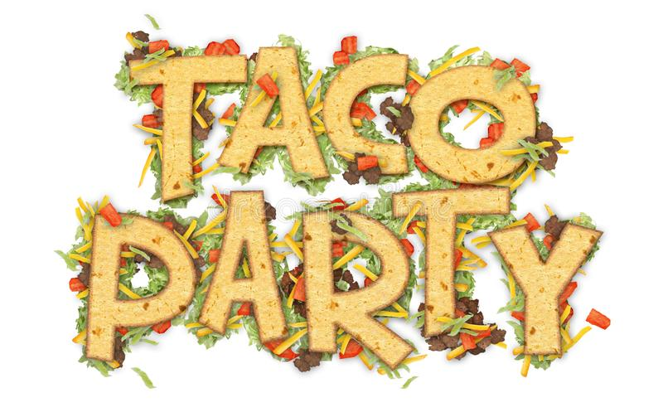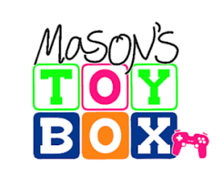

‘Taco’ ‘bout a good time!

Join us on November 12th

from 5:30pm to 7:30pm for Taco Tuesday!!

Mason’s Toy Box lends support to families impacted by childhood illness/disease in Central Virginia. Let’s help reach even more children and even more hospitals this year!

Help by donating a new, unwrapped toy! We will start collecting toys November 1st until December 14th.

**November**