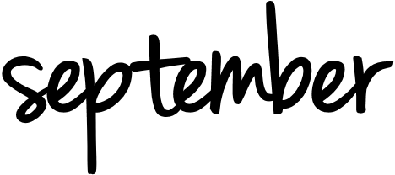
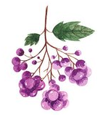
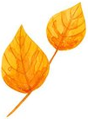
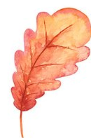
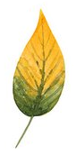
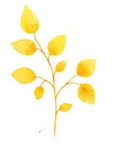
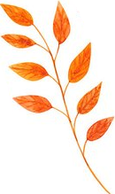
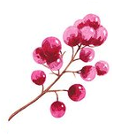
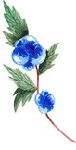
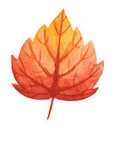
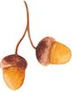
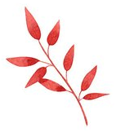
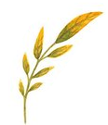

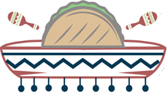
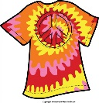
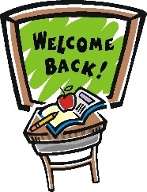
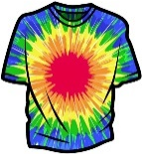
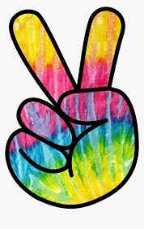
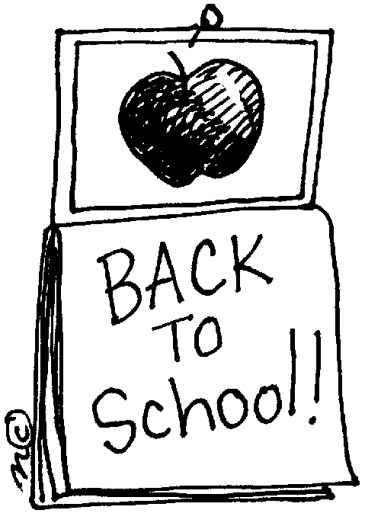
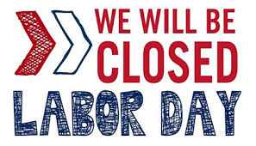
Two Brothers Southwestern Grill Food Truck 12PM to 2:30PM
- Sept. 19th
Winner will be selected!!!
Sept. 18th -
- Sept. 16th
Submit photo of your
Tie-Dye T-shirts
Sept. 14th -
Pick-up supplies &
Instructions for Tie-Dying
Contest BEGINS!!!
- Sept. 9th
Sign up for our
Tie-Dye T-shirt Contest!!!
We will be riding around on our golf carts passing out ice cream and popsicles
4PM to 5PM
ICE CREAM DAY!!
Sept. 8th -
- Sept. 8th
Kids 1st Day Back to School!
Sept.7th -

Resident Reminders

- Pay online 24/7!! If you do not have an account number, reach out to the office. We are happy to provide you with yours
- Maintenance work orders can be submitted online 24/7
- Quiet hours are from 10PM to 8AM. Please be respectful of your neighbors
- It is MANDATORY to pick up after your pets. All pets must be leashed at all times except for in the dog park. Failure to comply will result in a $50 fine
- Trash compactor runs on its own every 3rd time the door is closed, the lights flash & the machine begins beeping. DO NOT PUSH ANY BUTTONS. If the compactor is full, please call the office at 434-985-3270
- Please pick up packages within 7 days after delivery to the office
Sunday | Monday | Tuesday | Wednesday | Thursday | Friday | Saturday
 |  | 1 | 2 | 3 | 4 | 5
 |  |  | COCONUT DAY |  |  | NATIONAL CHEESE PIZZA DAY
6 | 7 | 8 | 9 | 10 | 11 | 12
NATIONAL READ A BOOK DAY | LABOR DAY  LEASING OFFICE CLOSED | KIDS GO BACK TO SCHOOL  ICE CREAM DAY 4P-5P | SIGN-UP FOR TIE-DYE  T-SHIRT CONTEST |  | 9/11 REMEMERANCE DAY | NATIONAL MILKSHAKE DAY
13 | 14 | 15 | 16 | 17 | 18 | 19
NATIONAL GRANDPARENTS DAY | TIE-DYE T-SHIRT CONTEST BEGINS PICK-UP SUPPLIES |  | SUBMIT PHOTOS/ TIE-DYE T-SHIRT CONTEST |  | WINNER SELECTED- TIE-DYE T-SHIRT CONTEST | FOOD TRUCK- TWO BROTHERS SOUTHWESTERN GRILL- 12P-2:30P
20 | 21 | 22 | 23 | 24 | 25 | 26
NATIONAL PEPPERONI PIZZA DAY |  | NATIONAL ICE CREAM CONE DAY |  |  | NATIONAL DAUGHTER’S DAY | FAMILY HEALTH AND FITNESS DAY
27 | 28 | 29 | 30
 | NATIONAL DRINK A BEER DAY

Upcoming Events & Holidays

