



Let’s see your creativity TG!!

Submit a photo of your Halloween door decorations for a chance to win a spooky prize!

All photos must be submitted to leasing@terracegreene.com by 10/26

WINNER announced 10/29!!!

**Halloween Door Decorating Contest**

**Terrace Greene is going to match all donations made!!**

**Make sure you come out and support the Virginia Breast Cancer Foundation!**

**Help us raise money for the VBCF from**

**October 1st to October 31st!!!**

**10/1-10/31: The Leasing Office will have *In Memory and In Honor* cards available for all donations given to the VBCF. All cards will be put on display on the windows of our office.**

**10/13 from 4PM to 6PM: Pumpkin patch for kids and adults!!**

**$5 minimum donation to the VBCF = 1 pumpkin**

**10/13-10/31: Chance to win prizes! Sponsored by Terrace Greene Apartments!**

**1 pumpkin = 1 raffle ticket = 1 entry into two different raffles.**

**Prize will be a TG $25 gift card & a grand prize Skyline Park Pass w/ snack basket**

**Raffle WINNER announced on November 1st!**

**For the whole month of October, we are partnering with the Virginia Breast Cancer Foundation!!!**

**Save The Pumpkins**

**Closed on Sundays**

**_________________**

**Oct. 10th office will be closing at 1:30PM**



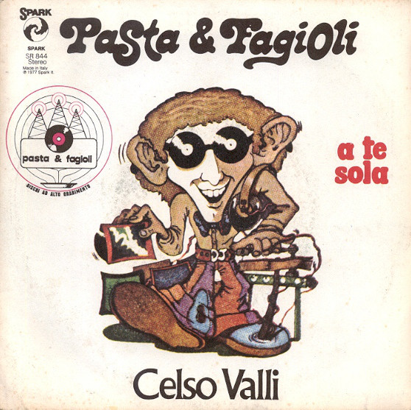

**Sombrero’s Cuisine** – 12PM to 3PM

October 3rd, 17th and 24th

**Firefly on the Fly Food Truck** – 5PM to 7:30PM

October 21st and 28th

* Pay online 24/7!! If you do not have an account number, reach out to the office. We are happy to provide you with yours
* Maintenance work orders can be submitted online 24/7
* Quiet hours are from 10PM to 8AM. Please be respectful of your neighbors
* It is MANDATORY to pick up after your pets. All pets must be leashed at all times except for in the dog park. Failure to comply will result in a $50 fine
* Trash compactor runs on its own every 3rd time the door is closed, the lights flash & the machine begins beeping. DO NOT PUSH ANY BUTTONS. If the compactor is full, please call the office at 434-985-3270
* Please pick up packages within 7 days after delivery to the office

Ingredients:

2 tbsp. extra-virgin olive oil

1/2 lb. spicy (or sweet) Italian sausage

1 yellow onion, finely chopped

2 carrots, peeled and finely chopped

2 stalks celery, finely chopped

3 cloves garlic, minced

Salt & pepper to taste

2 (15-oz.) cans Great Northern Beans

1 (15-oz.) can diced tomatoes

4 cups Chicken Broth

1 1/2 cup ditalini pasta (or other small shape)

Freshly grated Parmesan, for garnish

Freshly chopped parsley, for garnish

Directions:

1. In a large, deep pot over medium heat, heat oil. Add sausage and cook, breaking up with a wooden spoon, until cooked through, about 5 minutes. Stir in onion, carrots, and celery and cook until slightly softened, about 5 minutes.
2. Add garlic and cook until fragrant, 1 minute more. Season with salt and pepper, then add in beans (with their liquid), diced tomatoes, chicken broth, and rosemary. Bring to a boil, and then stir in ditalini.
3. Reduce heat to medium and cook until pasta is al dente, about 8 minutes. Taste and adjust seasoning if necessary.
4. Garnished with parmesan and parsley.

**Resident Reminders**