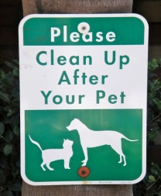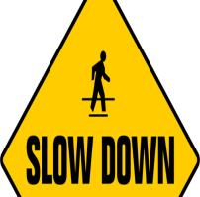

Leasing Office Holiday Hours and Closures:

December 24th and 25th - Closed

December 31st- Closing at 3pm

January 1st- Closed

Terrace Greene Events in December:

December 1st-

We will be giving way a prize every day for 25 days- Follow us on Facebook and Instagram for details.

December 9th-

Let’s Get Ugly- We provide the T-Shirt, you design the Ugliest Holiday T-Shirt, send pictures in, via our e-mail address at Leasing@terracegreene.com by the 15th, winner will be selected on the 18th.

















Terrace Greene Leasing Office: 434-985-3270

Fax Number: 434-985-1560

Terrace Greene Email: [Leasing@terracegreene.com](mailto:Leasing@terracegreene.com)

Terrace Greene Website: Terracegreene.com

Follow these tips during freeze warning: (temperatures below freezing) to avoid costly problems.

* **Keep your heat on, but not too hot:** turning your heat off is a bad idea during frigid temperatures; it can place heavy strain on the system. We recommend keeping heat between 65-68 degrees and to keep your heat on when you go out of town.
* **Be consistent with the temperatures:** only change thermostat by 2-3 numbers.
* **Leave a stream of running water:** Choose one faucet in your apartment and leave a small drip going. A little water flow reduces the risk of pipes freezing.
* **Keep windows closed and locked.**

How to prepare for freezing temperatures

The Terrace Greene Apartment Staff would like to take this opportunity to thank each and every one of you, our Terrace Greene Family! We hope you have a wonderful Holiday and a very happy New Year

Important contact information

Happy holidays from the Terrace Greene Team to yours!

December













Referral Bonus

When you refer someone to Terrace Greene Apartments and they move in, you receive a $200 referral bonus. Make sure they tell us on their first visit.

* Hayley’s Virtual Cooking Class
* Virtual BINGO!
* Resident Survey “How are we doing?”

Follow us on Facebook and Instagram every day to stay current on Terrace Greene Community news, event’s and chances to win PRIZES!

January Event’s

Remember to be respectful of your neighbors; quiet hours are from 10pm- 8am.

Quiet Hours

Pickup after your pet(s)

As the Holiday nears, the Leasing Office will be receiving a higher than usual volume of packages, please be kind and pick up your packages within 24-48 hours after you receive notification of delivery. **Remember**, ***the Leasing Office will be CLOSED December 24th and 25th.***

Packages delivered to Leasing Office

Picking up after your pet(s) is required. Your pet(s) must be on a leash at **ALL** times when they are not inside your home. Violations of these policies will result in a **$50.00** fine.

Please watch your speed throughout the community and make sure you are coming to a complete stop at **ALL** stop signs. The speed limit is 15mph.

Please slow down

Season’s greetings!



**Did you know?**

December 1st-

National Day of Giving

December 4th-

National Cookie Day

National Bartendar Day

December 7th-

National Cotton Candy Day

December 11th-

National Salesperson day

December 16th-

Chocolate Covered anything

Day

December 20th-

National Sangria Day

December 26th-

National Thank-you notes

Day

December 29th-

National Hero Day

December 31st-

New Year’s Eve





Community Reminders

Page 3 of 3

A favorite family phrase or slogan can go here.