

**february**

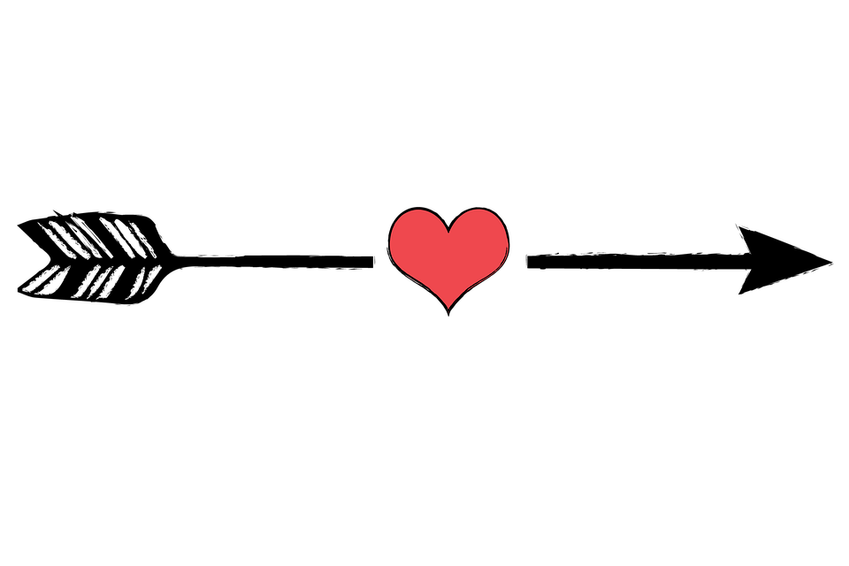

**CONTACT US:**

Leasing Office: 434-985-3270

Fax: 434-985-1560

Email: [Leasing@terracegreene.com](mailto:Leasing@terracegreene.com)

Website: Terracegreene.com

**FOOD TRUCK SCHEDULE**

***Take an afternoon off from cooking***

Twisted Biscuit- February 3rd- 11a-2p

El Tako Nako- February 13th- 11a-2p

Bavarian Chef- February 21st- 11a-2p

Martin’s Grill- February 27th- 11a-2p

February 16th- 6p

Sign up by end of the day February 10th; send us an email at [Leasing@terracegreene.com](mailto:Leasing@terracegreene.com)

Valentine’s Day Giveaway – February 12th, stay tuned for our Valentine’s GIVEAWAY!

**Win- It Wednesday’s** – follow us on Facebook and Instagram every Wednesday for a chance to WIN prizes. FB:facebook.com/terracegreene.com

IG:terrace_greene

**Kenny Gilbert** Maintenance Technician/Painter-Kenny was born in Charlottesville but moved around from South Carolina to West VA and back to Virginia.

Kenny has two sons, enjoys coaching basketball and baseball. He enjoys going to the beach, grilling, and playing sports. He has almost 20 years in the maintenance/building industry.



**Community Reminders**



**Did you know?-**

**February 1st**- National Get Up Day

**February 2nd**- National Groundhog Day

**February 4th**- Thank a Mail Carrier Day

**February 5th**- Wear Red Day

**February 6th**- Ice Cream for Breakfast Day

**February 9th**- National Pizza Day

**February 11th**- National Make a Friend Day

**February 14th**- Valentine’s Day

**February 15th**- President’s Day

**February 17th**- Random Acts of Kindness Day

**February 19th**- National Caregiver’s Day

**February 20th**- National Love Your Pet Day

**February 22nd**- National Margarita Day

Pickup after your pet (s)-

Picking up after your pet(s) is required. Your pet(s) must be on a leash at ALL times when you are not inside your home. Violations of these policies will result in a $50.00 fine.

Please slow down-

The speed limit around the community is 15mph.

Cardboard Dumpster-

Please BREAKDOWN all Cardboard boxes before putting them in the dumpster provided.