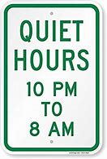

***Community Reminders* NAPRILEWSLETTER**

**Pickup after your Pet (s)**

Picking up after your pet(s) IS required. Your pet(s) MUST be on a leash at ALL times when you are not in the home. Violation of these policies will result in a $50.00 fine.



**COURTNEY NELSON**

**Leasing Consultant**

Courtney was born in Washington, DC and raised in Maryland. She recently relocated to the Charlottesville area after getting married. Courtney enjoys spending quality time with family and friends, being a mother, traveling, fishing, decorating and coordinating parties. She has spent over 13 years in the customer service field and is very excited to join the Terrace Greene Family.

**A Friendly Reminder**

Please be respectful of your neighbors between the hours of 10p-8am

**PLEASE SLOW DOWN**

The speed limit through the Community is 15mph.

**Cardboard Dumpster-**

Please BREAKDOWN ALL Cardboard boxes before putting them in the Cardboard dumpster provided.

**Did You Know?**

April 1st- April Fool’s Day

April 4th- Easter

April 5th- National Deep-Dish Pizza Day

April 7th- National Beer Day

April 11th- National Pet Day

April 15th- Tax Day

April 16th- National Wear Your PJ’s to Work Day

April 19th- National Hanging Out Day

April 22nd- National Earth Day

April 23rd- National Picnic Day

April 26th- National Kids and Pets Day

April 27th- National Tell a Story Day

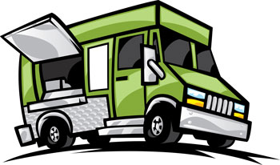

**April 19th-23rd**

Our Maintenance Team has been absolutely AMAZING throughout this year! We would like take this week and show them how much we appreciate them. If you see them around the community, please say Hi!

If you’d like to give them a shout-out, please email us at [Leasing@terracegreene.com](mailto:Leasing@terracegreene.com) and we will post it to our Facebook and Instagram. They would love to have a hand written card too.

**WITH THE EASTER BUNNY!!**

**April 3rd- 10-11a**

BOTH KIDS AND ADULTS CAN PARTICIPATE

LET’S PRACTICE SOCIAL DISTANCING

Place Baskets, bags, anything you can use, out on the sidewalk/walk-way. Basket must be visible from the road!

**THE EASTER BUNNY WILL WAVE & PLACE EGGS IN BASKETS!!**

**We will be wearing proper attire**

*WAVE from afar *

PLEASE LABEL ADULT BASKET

**\*\*CANDY & GIFT CARDS\*\***

April 28th- Bavarian Chef- 5p-7p

**Food Truck Schedule**

**Maintenance Appreciation Week-**

**April Events-**

April 3rd- Easter Egg Drop with The Easter Bunny - 10a-11a

April 19th-23rd – Maintenance Appreciation Week

***APRIL NEWSLETTER* NAPRILEWSLETTER**