

***July NEWSLETTER* NAPRILEWSLETTER**

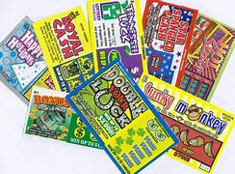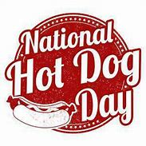

The Terrace Greene Team would like to wish you and yours a safe and Happy 4Th of July.

**Rent & Water Due**

**Rent and Water is ALWAYS due on the 1st of the month, you have until the 3rd of the month before you incur a late-fee.**

**Our Pay-Lease/Zego system will not upload rent or water if the 1st falls on the weekend, rent and water will upload on the next business day.**

**Please plan ahead, you can ALWAYS call the Leasing Office prior to the 1st of the month to inquire about your monthly rent amount.**

**Lottery Tickets**

**July 17th**

**The Terrace Greene Team will be celebrating National LOTTERY DAY!**

**5 lucky residents will have a chance to win!**

**Stay tuned for details**

July 21st – 5p-6:30p

The Terrace Greene Team will be celebrating National Hot Dog Day. We will be cooking Hot Dogs for our residents at both pools, come and join us!

**Hot Dog Social by the Pools**



**POOL GUEST**

**We allow 2 guest per household, pool capacity permitting**

**RESIDENT NOTICE**

**Any Residents and/or Residents guest refusing to obey pool rules is subject to removal from the premises and forfeiting use of pool amenities.**

**Pools will be monitored periodically after hours**.

**POOL HOURS**

9am – 9pm

**NO EATING IN POOL**

**Any person in the pool area eating shall be restricted to the area designated for eating, this area should be at least 3 feet from the pool edge.**

**NO LOUD MUSIC**

**Please be respectful of ALL residents who are enjoying the pool facilities, keep the music down.**

**Did You Know?**

**July 1st -**

National Postal Worker Day

**June 4th -**

4th of July

**July 10th -**

National Kitten Day

**July 15th -**

National Give Something Away Day

**July 17th -**

National Lottery Day

**June 20th -**

National Lollipop Day

**July 21st -**

National Hot Dog Day

**July 24th –**

National Cousin Day

**July 31st -**

National Mutt Day