



***Happy Easter***

**April 17th – Terrace Greene Staff would like to wish you and yours a very Happy Easter!**

***April Events-***

**April 16th - Easter Egg Drop with The Easter Bunny - 10a-11a**

**April 30th – Community Yard Sale 8a-12p**

***TG COMMUNITY YARD SALE***

When: April 30th, 8a-12p

Where: Throughout the Community

Time to clean out those closets, garages and storages areas!

**WITH THE EASTER BUNNY!!**

**April 16th- 10-11a**

BOTH KIDS AND ADULTS CAN PARTICIPATE

Place Baskets, bags, anything you can use, out on the sidewalk/walk-way. Basket must be visible from the road!

**THE EASTER BUNNY WILL WAVE & PLACE EGGS IN BASKETS!!**

TAKE A PICTURE with the Easter Bunny

**\*\*CANDY & GIFT CARDS\*\***

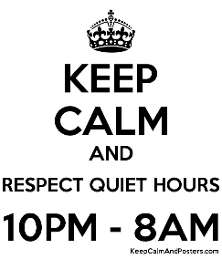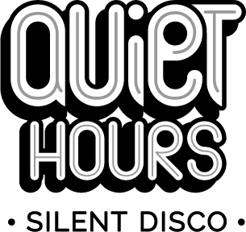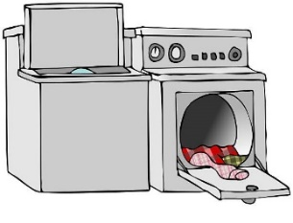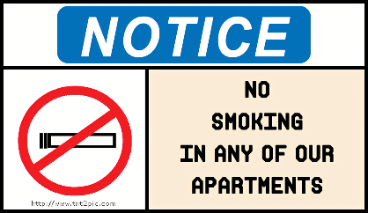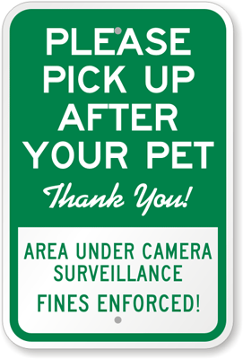

***Community Washers/Dryers***

**Please be courteous of other residents and remove your laundry once your laundry has completed its cycle.**

***Paying Rent by Check or Money Order***

**Please make sure you include your apartment number on your checks or money order to ensure your rent payment is being applied to the correct account.**

***No Smoking Inside Buildings/Apartments/Townhomes***

**Smoking, ALL forms of tobacco and non-tobacco products, anywhere inside buildings of the community is strictly prohibited.**

**We allow smoking on balconies, patios and common areas.**

***Pickup after your Pet (s)***

**Picking up after your pet(s) IS required. Your pet(s) MUST be on a leash at ALL times when you are not in the home. Violation of these policies will result in a $50.00 fine.**

***Reminders***

***Community***