



**TG is in a SWIMMING state of mind, GOOD TIMES and TANLINES!**

**POOL HOURS- 8a-9p, 7days a week**

**Memorial Day**

**May 29th - Leasing Office will be CLOSED**

**We are celebrating Mother’s on May 12th.**

**We Will Have a Mother’s Day GIVEAWAY! Stay tune for details.**

***COMMUNITY EVENTS:***

**May 4th – Twisted Biscuits –**

**5p – 7:30p**

**May 12th – Mother’s Day Giveaway**

**May 29th – Memorial Day – Leasing Office - CLOSED**

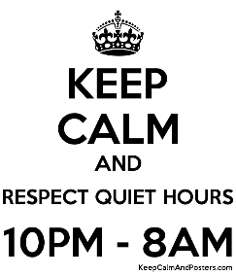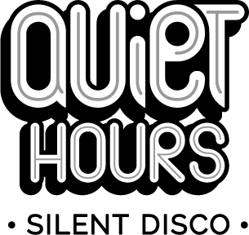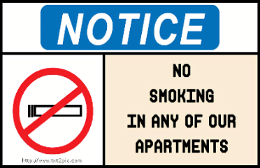

***Our Online Portal***

**Our Online Portal, Active Building/ RealPage is active. Please be sure to sign-up. You can see your account, pay your rent/water/sewer etc. and put in a Service Request.**

**You can still pay by check/money order in the Leasing office.**

***Pickup after your Pet (s)***

**Picking up after your pet(s) IS required. Your pet(s) MUST be on a leash at ALL times when you are not in the home. Violation of these policies will result in a $50.00 fine.**

***No Smoking Inside Buildings/Apartments/Townhomes***

**Smoking, ALL forms of tobacco and non-tobacco products, anywhere inside buildings of the community is strictly prohibited.**

**We allow smoking on balconies, patios and common areas.**