Happy St. Patrick's Day - Society Of Happy People

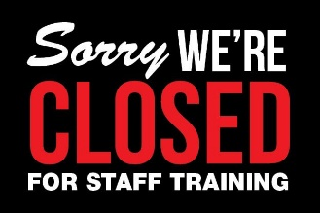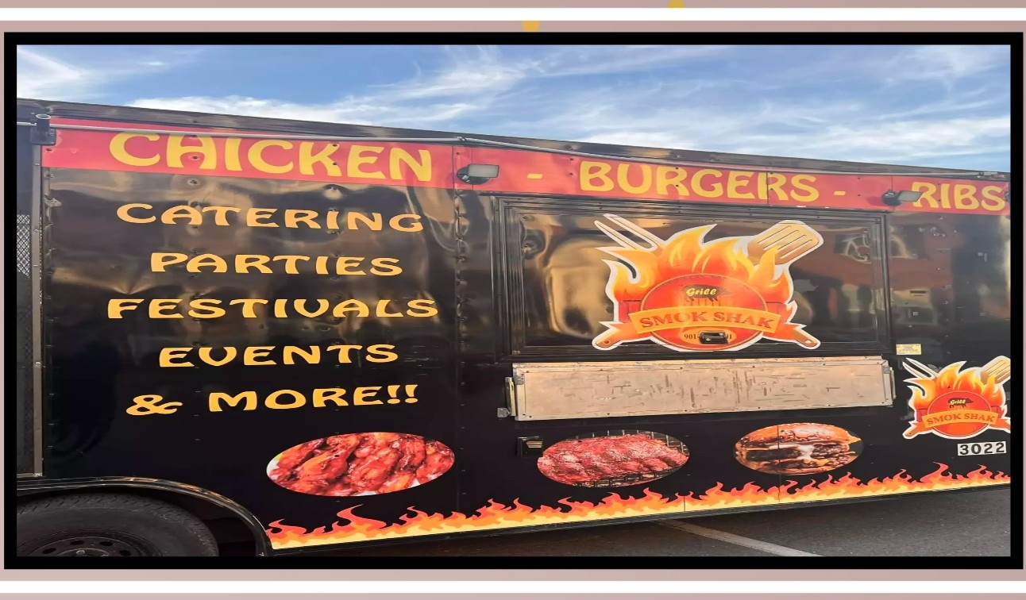Happy St. Patrick's Day - Society Of Happy PeopleHappy St. Patrick's Day - Society Of Happy PeopleHappy St. Patrick's Day - Society Of Happy People

**The Leasing Office will be CLOSED March 19th for Staff Training**

**9a- 3:30p**

**March 31st – Terrace Greene Staff would like to wish you and yours a very Happy Easter!**

**Do not forget to Spring Forward an Hour**

**March 10th**

**Smok-Shak Food Truck:**

**When: March 29th**

**Where: In Front of the Leasing Office**

**Time: 4:30p-7:30p**

**Terrace Greene Annual St. Patrick’s Day Party**

**When: Wednesday, March 13th**

**Where: Community Room, Building 15**

**Time: 6p-7:30p**

**\*\*Don’t forget to wear GREEN\*\***

**WITH THE EASTER BUNNY!!**

**March 23rd – 12p-2p**

BOTH KIDS AND ADULTS CAN PARTICIPATE

**THE EASTER BUNNY WILL BE DRIVING AROUND THE COMMUNITY, WAVING & PLACING EGGS IN YOUR EASTER BASKET, DON’T FORGET TO LOOK FOR SOME EXCITING PRIZES FOR THE ADULTS TOO !!**

Don’t forget to TAKE A PICTURE with the Easter Bunny

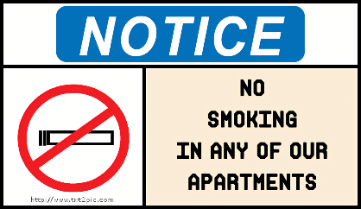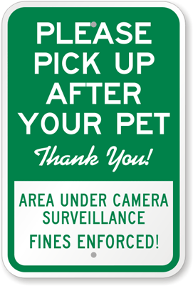Happy St. Patrick's Day - Society Of Happy PeopleHappy St. Patrick's Day - Society Of Happy PeopleHappy St. Patrick's Day - Society Of Happy PeopleHappy St. Patrick's Day - Society Of Happy People

**The compactor runs on its own! When the red-light flashes & it beeps, the compactor is running.**

**Do not press any buttons or open the compactor door. If the compactor is full, call the office.**

**\*\*\* Video footage running 24/7 @ compactor\*\*\***

**Residents/Guests putting anything outside of the compactor that would require us to haul to the dump will be result in a fee charged directly to their account. Anyone caught not breaking down boxes fully will also result in a $50 fee for blocking up the compactor.**

***No Smoking Inside Buildings/Apartments/Townhomes***

**Smoking, ALL forms of tobacco and non-tobacco products, anywhere inside buildings of the community is strictly prohibited.**

**We allow smoking on balconies, patios and common areas ONLY.**

***Pickup after your Pet (s)***

**Picking up after your pet(s) IS required. Your pet(s) MUST be on a leash at ALL times when you are not in the home. Violation of these policies will result in a $50.00 fine.**

**Outside of the Dog Park area; all pets must be on a leash at all times.**

***Our Online Portal***

**Our Online Portal, Active Building/ RealPage is active. Please be sure to sign-up. You can see your account, pay your rent/water/sewer etc. and put in a Service Request. To avoid service fee’s, choose the E-Check option when paying online.**

**You can still pay by check/money order in the Leasing office.**

***Reminders***

***Community***