

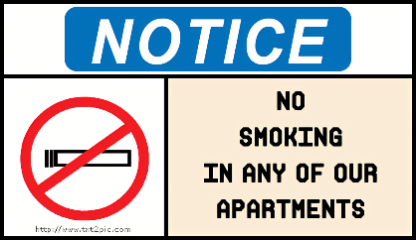

**The compactor runs on its own! When the red-light flashes & it beeps, the compactor is running.**

**Do not press any buttons or open the compactor door. If the compactor is full, call the office.**

**\*\*\* Video footage running 24/7 @ compactor\*\*\***

**Residents/Guests putting anything outside of the compactor that would require us to haul to the dump will be result in a fee charged directly to their account. Anyone caught not breaking down boxes fully will also result in a $50 fee for blocking up the compactor.**

***No Smoking Inside Buildings/Apartments/Townhomes***

**Smoking, ALL forms of tobacco and non-tobacco products, anywhere inside buildings of the community is strictly prohibited.**

**We allow smoking on balconies, patios and common areas ONLY.**

***Pickup after your Pet (s)***

**Picking up after your pet(s) IS required. Your pet(s) MUST be on a leash at ALL times when you are not in the home. Violation of these policies will result in a $50.00 fine.**

**Outside of the Dog Park area; all pets must be on a leash at all times.**



**Breakfast on the GO!**

**When: April 24th**

**Where: In Front of the Leasing Office Mailboxes**

**Time: 6:30a-8:30a**

**Smok-Shak Food Truck:**

**When: April 19th**

**Where: In Front of the Leasing Office**

**Time: 4:30p-7:30p**

**4/1: Cereal Bar - 9:30a-10:30a**

**4/2: Create a Planter - 2p-4p**

**4/3: Movie Day - 3p-5p**

**4/4: Vitamin Day – All Day – Stop by the Leasing Office and grab some “Sunshine”.**

**4/5: Popsicle Social – 2p-3p**

**5pts- Picture of a Pet**

**10pts- Post a selfie in one of our gyms**

**10pts- Take a selfie & post by one of our pools**

**15pts- Find a pair of TG Sunglasses hidden around the Community**

**20pts- Post a picture of our Maintenance Tech working**

**10pts- Post a selfie in front of the Leasing Office**

**20pts- Find our hidden TG Business Cards and bring to the Leasing Office.**

**Terrace Greene Staff Invites you to week worth of “Spring Break” FUN at the Leasing Office!**

**TG Community Scavenger Hunt**

**Wednesday April 10th**