

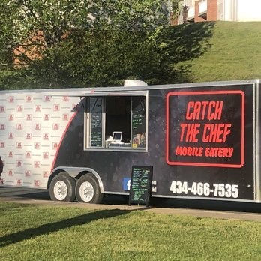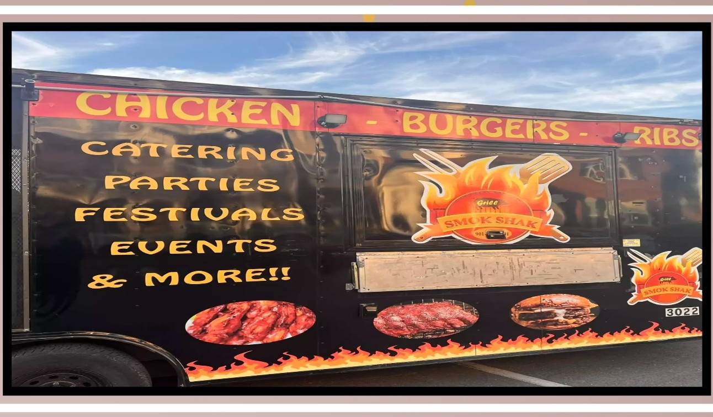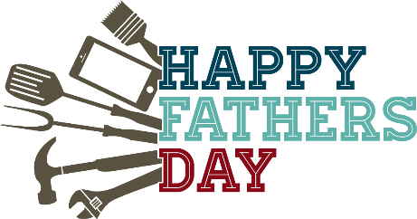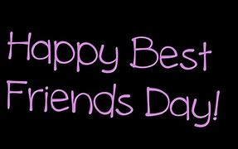

**June 7th – Catch a Chef – 4:30p – 7:30p**

**June 8th - Best Friend Giveaway**

**June 13th - Father’s Day Giveaway**

**June 28th – Smok- Shak – 4:30p – 7:30p**

**Catch the Chef:**

**When: June 7th**

**Where: In Front of the Leasing Office**

**Time: 4:30p-7:30p**

**Smok-Shak Food Truck:**

**When: June 28th**

**Where: In Front of the Leasing Office**

**Time: 4:30p-7:30p**

**Father’s Day Giveaway**

**June 13th, Father’s Day Giveaway!**

**TG Team would like to thank all the Father’s!**

**Stay tuned for details on our Father’s Day Giveaway**

**Join us in celebrating your Best Friend.**

**We will have a “BEST FRIEND GIVEAWAY!” Post a picture of you & your best friend on Facebook, June 8th from 10a-3p, TG will choose a WINNER**

**Prize- Dinner for 2**

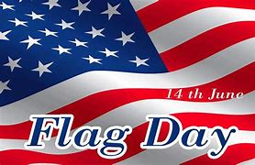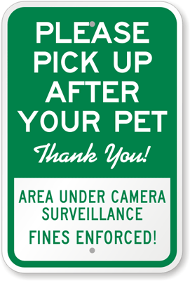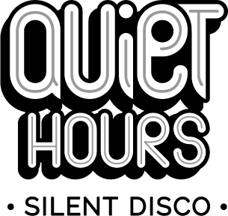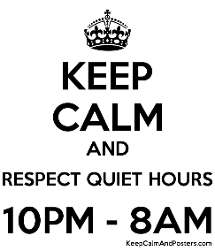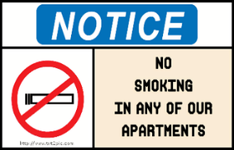

**Did You Know?**

**June 1st –**

National Pen Pal Day

**June 2nd –**

National Cancer Survivor’s Day

**June 7th –**

National Donut Day

**June 8th –**

National Best Friend’s Day

**June 9th –**

National Children’s Day

**June 14th –**

Flag Day

**June 16th –**

National Father’s Day

**June 21st –** National Selfie Day

**June 21st –**

Take Your Dog to Work Day

**June 27th –**

National Sunglasses Day

***Paying Rent by Check or Money Order***

**Please make sure you include your apartment number on your checks or money order to ensure your rent payment is being applied to the correct account.**

***Pickup after your Pet (s)***

**Picking up after your pet(s) IS required. Your pet(s) MUST be on a leash at ALL times when you are not in the home. Violation of these policies will result in a $50.00 fine.**

***No Smoking Inside Buildings/Apartments/Townhomes***

**Smoking, ALL forms of tobacco and non-tobacco products, anywhere inside buildings of the community is strictly prohibited.**

**We allow smoking on balconies, patios and common areas.**