



**The Terrace Greene Team would like to wish you and yours a safe and Happy 4Th of July.**

**The Leasing Office will be CLOSED**

**July 15th**

**The Terrace Greene Team will be celebrating National LOTTERY DAY!**

**15 lucky residents will have a chance to win!**

**Stay tuned for details**

**Lottery Tickets**

**July 17th – 6p-7:30p**

**The Terrace Greene Team will be celebrating National Hot Dog Day.**

**We will be cooking Hot Dogs for our residents at the Leasing Office pool, come and join us!**

**Hot Dogs, Chips and Drinks**

**Hot Dog Social**

**by the Pool**

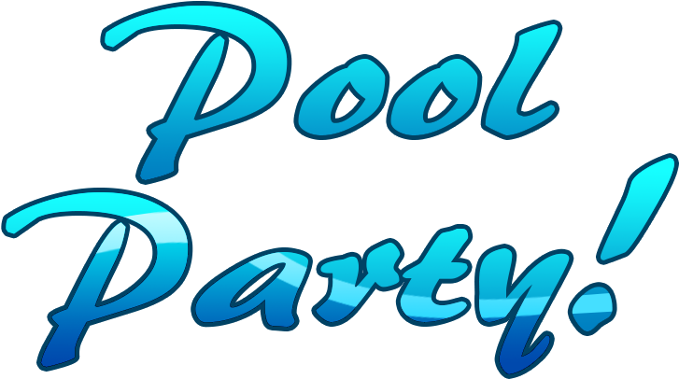

**RESIDENT NOTICE**

**Any Residents and/or Residents guest refusing to obey pool rules is subject to removal from the premises and forfeiting use of pool amenities.**

**Pools will be monitored periodically**.



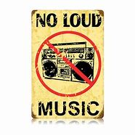

**NO LOUD MUSIC**

**Please be respectful of ALL residents who are enjoying the pool facilities, keep the music down.**







**NO GLASSWARE**

**There is no glassware of any kind allowed in the pool area.**



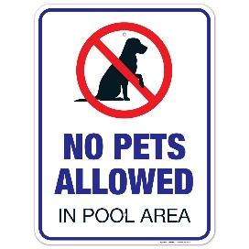

**NO PETS ALLOWED**

**No pets allowed in the Pool area or in the Pool.**



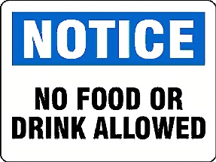

**NO FOOD OR DRINKS ALLOWED**

**No Food or Drinks allowed in the pool.**

