



**and**

**Join us Wednesday**

**January 15th - 6p-7:30p**

**Leasing Office Clubhouse**

**Food * Fun * Drinks * Prizes**

**Premier Baking Co. Food Truck**

**Saturday - Jan 18th – 10a – 2p**

**Leasing Office Closings:**

**Jan 1st -Leasing Office** **will be** **CLOSED**

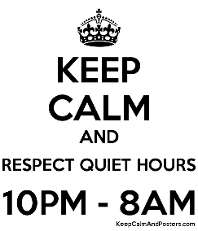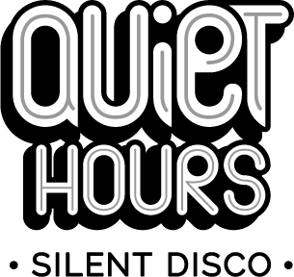

**Important Contact Information**

**Terrace Greene Leasing Office- 434-985-3270**

**Fax Number- 434-985-1560**

**Terrace Greene Email-** [**Leasing@Terracegreene.com**](mailto:Leasing@Terracegreene.com)

Terrace Greene Website- Terracegreene.com

***Community Reminders:***

**Delivered Packages- USPS packages should be picked up from the Leasing Office within 24 after you have been notified.**

**Referral Bonus-When you refer someone to Terrace Greene Apartments and they move in, YOU receive a $200 referral bonus. Make sure they tell us on their first visit.**

**Work Orders- Please submit all work orders through ActiveBuilding Online Portal.**

**Pickup after your Pet (s)-**

**Picking up after your pet(s) IS required. Your pet(s) MUST be on a leash at ALL times when you are not in the home. Violation of these policies will result in a $50.00 fine.**

**Cardboard Dumpster-**

**Please BREAKDOWN ALL Cardboard boxes before putting them in the Cardboard dumpster provided.**

***Reminders***

***Community***